Thank you for your interest to Volunteer with Cal-Diego PVA

Many of our volunteer opportunities take place within the VA San Diego Healthcare System. Before beginning a volunteer assignment with SCI Unit/Cal-Diego PVA at the VA, volunteers must complete the VA volunteer onboarding process through the Center for Development & Civic Engagement (CDCE), formerly Voluntary Services.

*Student Volunteers*

Students 16 and older are welcome to apply. Volunteers under 18 will need parent or guardian permission as part of the VA application process.

If you are completing volunteer hours for school, a scholarship, or community service, we recommend starting early. Please follow the steps below to complete the VA onboarding process before beginning your volunteer hours.

If your school requires verification of hours, signatures, paperwork, or completion by a specific deadline, please let Cal-Diego PVA know in advance.

Step 1: Start Your VA Volunteer Registration
Start here by scanning the VA Volunteer QR Code.
When prompted, select:
- State: California
- Facility Site: San Diego VA HCS 664

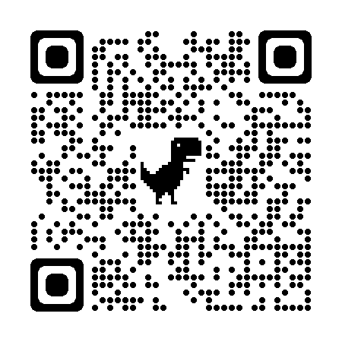

Step 2: Complete the VA Volunteer Application
Complete the Application for Voluntary Service, VA Form 10-7055.
Please complete all applicable sections of the application and return them to VA Volunteer Services at Jennifer Moreno VA La Jolla.
Download VA Volunteer Application

Step 3: Schedule Fingerprinting
Only ADULT volunteers 18 and older are required to complete fingerprinting.
TEEN 16-18 Volunteers under 18 do not require fingerprinting.
Fingerprinting is available Tuesday through Thursday, 7:00 a.m. to 3:00 p.m. Bring two forms of state or federal identification.
To schedule, contact VA Volunteer Services: 858-642-3267.

Step 4: Complete Your VA Orientation and Training
Review the VA San Diego Orientation Packet, complete the required training and quizzes, and sign the Statement of Commitment and Understanding.
Print the completed forms, sign and date where required, and bring them with you to VA Volunteer Services Office at Jennifer Moreno VA La Jolla
Volunteer Orientation and Training: Review the VA San Diego orientation packet and complete the required training sections, including privacy, confidentiality, HIPAA, and the Privacy Training and Volunteer Competency quizzes.
Tuberculosis symptom screening: Complete the TB symptom screening form, initial the required statements, and sign and date the form.
Integrity and Compliance Awareness: Review the Integrity and Compliance Awareness information, then print your name, sign, and date the form.
Professional appearance and hygiene requirements: Review the VA San Diego standards for professional dress, grooming, footwear, hygiene, and identification badge requirements while volunteering.
Additional health or safety documentation required by VA San Diego: Provide a current copy of your immunization record as part of the VA volunteer onboarding process.

Step 5: VA Clearance and Identification Badge

Take your completed volunteer packet to VA Volunteer Services for review. They will complete the required clearance process and provide instructions on how to obtain your VA volunteer identification badge.
Do not begin your volunteer assignment until VA Volunteer Services confirms you are cleared to start.

Once you begin volunteering, you will need to check in each time you report to the VA so your volunteer hours are properly recorded and you are accounted for in the hospital.

Questions or Need Help Getting Started?
VA San Diego Center for Development & Civic Engagement (CDCE)
Formerly Voluntary Services
Jennifer Moreno Department of Veterans Affairs Medical Center
3350 La Jolla Village Drive
San Diego, CA 92161
Phone: 858-642-3267
Fax: 858-642-6307
For questions about volunteer opportunities with Cal-Diego PVA, please contact us directly.

